University of Nottingham

MM2TF2

Thermodynamics and Fluid Mechanics

Air conditioning and refrigeration

Name: Deen Sooky

Student ID: 20157875

Submission Date: 13/12/2021

Contents

Summary 1

Results 1

Discussion 6

Conclusion 6

# Summary

To understand air conditioning processes and the indicators of moisture and heat content of the environmental air [1]. The main objectives of this experiment were to analyse these processes using a psychrometric chart to seize the air energy and absolute humidity. Then using a p-h diagram (absolute pressure – specific enthalpy diagram) to find the energy change of refrigerant across the cooling heat exchanger.

Based off the findings from the experiment the theoretical data did not quite match the experimental data that was discovered, indicating there were errors, either with equipment or the way that the data was collected. For example, the greatest contrast between the experimental data and the theoretical data was the data collected at point C (the point at where both bulbs are cooled after the first heating). The temperature of the dry and wet bulb that was recorded 15.6°C and 13.9°C respectively, whereas the temperature according to the theoretical data of the dry and wet bulb were 20.5°C and 17.5°C.

# Results

**Air side data (figure,1)**

|  |  |  |  |  |  |  |  |  |  |  |  |
| --- | --- | --- | --- | --- | --- | --- | --- | --- | --- | --- | --- |
| **air side data** | **1** | **2** | **3** | **4** | **5** | **6** | **Mean** | **Max** | **Min** | **SD** |  |
| Tdb-in | 16 | 16.8 | 16.6 | 16.8 | 17.4 | 17 | 16.8 | 17.4 | 16 | 0.4633213 |  |
| Twb-in | 12.5 | 12 | 12 | 12 | 12.5 | 12.5 | 12.3 | 12.5 | 12 | 0.2738613 |  |
| Tdb-after-heat | 28 | 26 | 28.5 | 28 | 28.8 | 28.5 | 28 | 28.8 | 26 | 1.0132456 |  |
| Twb-after-heat | 20.8 | 20.4 | 21 | 20 | 20 | 20.8 | 20.5 | 21 | 20 | 0.4335897 |  |
| Tdb-after-cool | 14.5 | 16 | 16 | 15 | 16 | 16 | 15.6 | 24.1 | 21.4 | 0.6645801 |  |
| Twb-after-cool | 14 | 14.5 | 14 | 13 | 14 | 14 | 13.9 | 14.5 | 13 | 0.491596 |  |
| Tdb-after-2nd-heat | 27.8 | 27.6 | 27.8 | 27.8 | 28 | 28 | 27.8 | 28 | 27.6 | 0.1505545 |  |
| Twb-after-2nd-heat | 17.5 | 17.5 | 17 | 17 | 17.5 | 17.5 | 17.3 | 17.5 | 17 | 0.2581989 |  |
| manometer reading | 4.4 | 4.3 | 4.3 | 4.4 | 4.3 | 4.3 | 4.3 | 4.4 | 4.3 | 0.0516398 |  |

Figure,1 – Shows the table of air side data

**

D

C

B

A

Figure, 2 shows the four different thermometer points as mean values

**Air side theoretical data** (figure,3)

|  |  |  |  |
| --- | --- | --- | --- |
| Point | Dry bulb Temperature ( | Wet bulb Temperature ( | Enthalpy |
| A | 24 | 17 | 46 |
| B | 34.5 | 23.5 | 69 |
| C | 20.5 | 17.5 | 48 |
| D | 31.5 | 20 | 56.5 |

|  |  |  |  |  |  |  |  |  |  |  |  |
| --- | --- | --- | --- | --- | --- | --- | --- | --- | --- | --- | --- |
| **Refrigerator data** | **1** | **2** | **3** | **4** | **5** | **6** | **Mean** | **Max** | **Min** | **SD** |  |
| T-evap out | 9 | 9 | 8 | 9 | 9 | 9 | 8.825048 | 9 | 8 | 0.408248 |  |
| T-compressor out | 69 | 68 | 68 | 69 | 69 | 69 | 68.66504 | 69 | 68 | 0.516398 |  |
| T-condenser out | 33 | 33 | 33 | 33 | 33 | 33 | 33 | 33 | 33 | 0 |  |
| p-high, bar absolute | 10 | 10 | 10 | 10 | 10 | 10 | 10 | 10 | 10 | 0 |  |
| p-low, bar absolute | 2.9 | 2.8 | 2.8 | 2.8 | 2.8 | 3 | 2.848996 | 3 | 2.8 | 0.083666 |  |
| Refrigerator mass | 11 | 11.3 | 11.2 | 11.5 | 11.3 | 11.2 | 11.249 | 16 | 11 | 0.164317 |  |
| condensate collection | 205 | 135 | 100 | 103 | 510 | 150 | 167.1467 | 510 | 100 | 156.3698 |  |
| condensate collection time | 9.3 | 6.2 | 4.4 | 5 | 25.2 | 4 | 7.097842 | 25.2 | 4 | 8.155101 |  |

**Refrigerator Data** (Figure, 4)

Figure,4 – Shows the table of refrigerator data

**Refrigerator cycle Pressure-Enthalpy diagram** (Figure, 5)

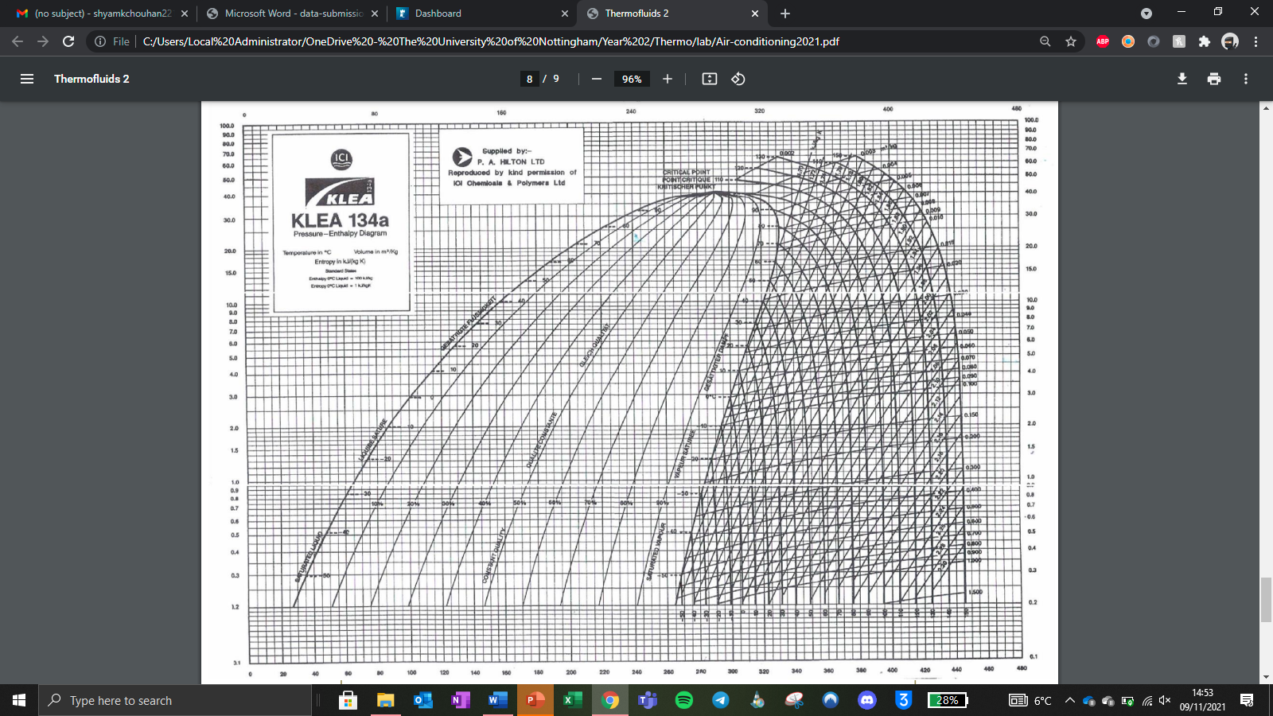

**Condenser exit**

**Compressor exit**

**Evaporator exit**

**Refrigerator theoretical data** (figure,6)

|  |  |  |
| --- | --- | --- |
| Process | Temperature ( | Pressure 9 bar abs) |
| Evaporator exit | 10 | 3 |
| Compressor exit | 70 | 10 |
| Condenser exit | 40 | saturated |
| Enthalpy across evaporator () | Mass flux of refrigerant () | Cooling (KW) |
| 307-157 | 0.015 | 2.25 |

# Calculations

**Mass flow rate of air**

∆z = Mean manometer reading = 4.3mm

Vd = Specific volume of air = 0.79

therefore

**Enthalpy Calculations**

Enthalpy for points A and B = ∆h= 53-36 = 17 KJK

**Energy calculation**

= x ∆h = 0.121 x 17 = 2.01 KW

**Condensate calculation**

# Discussion

First, it’s important to note that the main aim of this experiment “To understand air conditioning processes and the indicators of moisture and heat content of the environmental air” [1]. Secondly when looking at the theory behind this experiment it states that the temperature of the wet bulb should be lower than the temperature of the dry bulb, this is because there is evaporation when the relative humidity is not 100%. As a result of this evaporation the wet bulb would have a lower temperature.

From figure 1, you can see the different points at which the temperature was measured from the rig and its corresponding humidity at each point. For example, from figure 1 you can see the humidity rise due to the addition of heat and steam from points A to B. Furthermore, from points B to C you can see the cooling of the air therefore there’s a steep decrease in the temperature of the air. Finally, from points C to D you can see a slight decrease in humidity as well a slight increase in temperature.

It’s important to compare the experimental data to the theoretical data as these differences could indicate possible errors. As with any experiment there is a degree of error and uncertainty, some of which you can control and others which you cannot control. For example, a systematic error that could have interfered with the data collection was the reading of the thermometers because they tend to fluctuate quite as well as the readings on them were quite hard to see resulting in less accurate data collection therefore there was also room for human error. To reduce the uncertainty of my data collection as much as possible, 6 results for each variable were measured and a mean was taken, the instruments used in the experiment also had uncertainties for example, the thermometers had an uncertainty value that ranged between ±0.1 and ±1 depending on the thermometer used from the rig. The condensate collection had an uncertainty of ±5, the manometer had an uncertainty of ±0.1 and finally the uncertainties of the collection time and refrigerant mass rate were both ±1.

# Conclusion

Since the experiment was conducted in a control environment it is clear the lab was in fact atmospheric, the rig also showed how the behaviour of air changed after the addition of steam or cooling of the air which is demonstrated by figure 1. Furthermore, from the data collected and the extrapolation of this data you can see the refrigerant cycle as stated in the theory [1] as well as the thermodynamic principles that cause this cycle. Overall, the aims of this experiment were met as the rig did decrease the temperature of the air as it entered through the heat exchange of the refrigerant.

# References

[1] - file:///C:/Users/Local%20Administrator/OneDrive%20-%20The%20University%20of%20Nottingham/Year%202/Thermo/air%20conditioning%20lab/Air-conditioning2021.pdf

# 